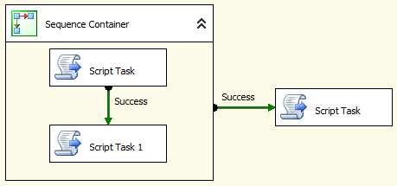

**Example**

1. Add a package variable **DayOfWeek**

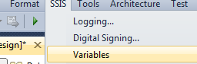

[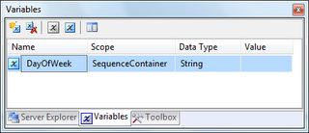](http://1.bp.blogspot.com/_2t15yG-FxQA/TB7RA7hF6DI/AAAAAAAAApk/xBYu5LSmkCc/s1600/1.png)

2. Drag and drop **Script Task** from toolbox. This task will be used to initialize **DayOfWeek** variable with current day of week. Rename Task name as **Script Task - Set DayOfWeek**.

3. Double click on Script Task to open *Script Task Editor*. Enter **User::DayOfWeek** in ReadOnlyVariables property.

4. Click on **Edit Script...** and write below code in **Main()** function of ScriptMain.cs:

public void Main()

{

String dayOfWeek = String.Format("{0:dddd}", DateTime.Now);

Dts.Variables["User::DayOfWeek"].Value = dayOfWeek;

MessageBox.Show("Day of Week = " + dayOfWeek);

Dts.TaskResult = (int)ScriptResults.Success;

}

5. Drag and Drop **7 Sequence Container tasks** from Toolbox and rename the task on Week Days e.g. "SC - Sunday", "SC - Monday" etc.

6. Connect all these Sequence Containers to **Script Task**.

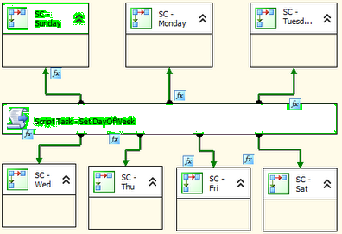

7. Now **double click** on green arrow to open **Precedence Constraint Editor**.

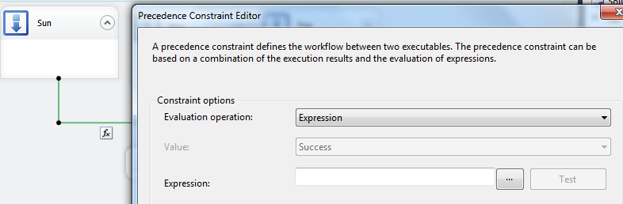

Select Evaluation operator as **Expression and Constraint**

And Expression as **@DayOfWeek == "Sunday"**.

Click OK and save changes. The Expression for remaining task will be differ as per week day e.g. **@DayOfWeek == "Monday"** for Monday and so on.

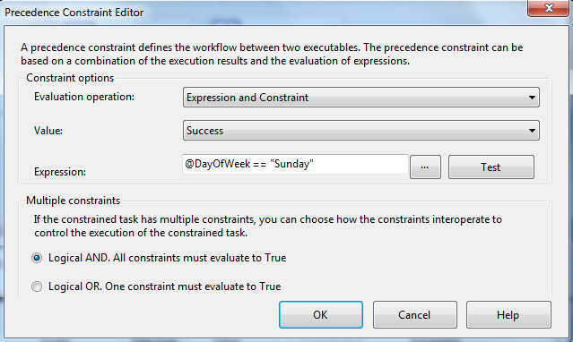

8. Save the package. Now right click on the package in Solution Explorer and execute the package.

[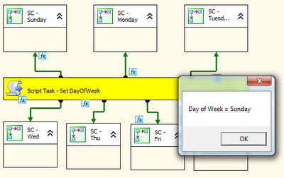](http://4.bp.blogspot.com/_2t15yG-FxQA/TB7pMBEXYwI/AAAAAAAAAp8/4zbVfZBdrYw/s1600/1.png)

9. This package will execute only one sequence container as per expression set for the precedence constraints.